AI Canvas + Crosswork AI Demo Scripts

Script-1:
Frame | Visual | Talk Track | Notes
1 | Message from @crossworkAI that network issues have been detected in the network, with a link for more info.  Message shown in C3:  “Severity Level: High  An anomaly has been detected for service <service id, service name> with service endpoints <blah>. An increase of <x%> compared to baseline delay values has been detected. To analyze this issue in AI Canvas, go to <link>.” | One of the biggest advantages of agentic operations is that you can have persistent agents that constantly scan for issues - compliance, security, performance - you name it.  Looks like one of our Crosswork Network Controller AI agents has detected an anomaly on the network. Delay is up <%> compared to baseline values. Let’s see what is happening  [click on ‘more’ link]
2 | AI Canvas window opens the associated board with the AI Assistant showing the same message as the previous message (“An anomaly has been detected for service <service id>. An increase of <x%> compared to baseline delay values has been detected”).  User clicks to add a card to the canvas with the message details (card-1).  Button is provided suggesting next step:  “Get more details on the detected anomaly”  User selects this. | Through Cloud Control, Cisco’s unified management platform,  AI Canvas opens a window tied to the alert. We can pin the details into the Canvas so they’re captured in the timeline, and then click the suggested next step to pull more context on the anomaly.
3 | AI Assistant responds: “Thinking…  Checking with Crosswork Network Controller AI.  Fetching information from PCA and  CNC.  Analyzing service assurance graph from CNC.  Checking for health issues on associated devices.  Two symptoms causing service health degradation. Both seem to be correlated as they are both reporting latency spikes between the same endpoints (PE-A, PE-B).  Checking for delay increases on the links along the service path.  The links along the service path have not experienced delay increases.  Checking event history for associated SR policy.  A path change has been identified for the SR policy within the past hour.  Potential reason for path change could be a configuration change.  Recommendation: Check for anomalous configuration changes.  Preparing results.  Analyzed service assurance graph. Degradation issues identified on the transport level. A path change has been identified for the SR policy around the anomaly detection time.  Recommendation: Check for anomalous configuration changes.  ”  The following cards are added to the board:  Card-2: Line chart with delay of service <service id> over time (e.g., last week) – may also include baseline info here.  Card-3: Expanded service assurance graph showing everything “green” – except for the path SLA node and the PE-A VPN node and respective child nodes reporting symptoms.  Card-4: Topology view with traversed nodes/links highlighted in another color. Subset of topology may be shown, or node clustering may be provided. (Note: If this is not possible, we can just show the service path without neighboring nodes)  Button is provided suggesting next step:  “Perform configuration drift detection” | Crosswork Network Controller AI fetches information to analyze what’s happening along the service path.  Based on service assurance graph analysis, degradation issues have been identified on the transport level. Furthermore, a path change has been identified around the anomaly detection time.  The recommendation is to check for anomalous configuration changes that may have caused this.
4 | User invites additional Operations/Engineering folks to the board – via “Share”, “Generate AI Summary”, and “Invite”. | This isn’t the kind of issue you want to troubleshoot alone. . Let’s share this board with additional folks to work on this together.
5 | User selects “Perform configuration drift detection” button. | Now, we’ll follow the suggestion and run the configuration drift detection agent to check for anomalous network configurations .
6 | AI Assistant responds “Thinking…  Checking with Crosswork Network Controller AI for configuration drift.  Checking for devices with configuration changes since latest scheduled configuration drift detection run.  Configuration changes identified for devices <x> and <y>.  Fetching configurations from CNC.  Analyzing configurations against configuration language models.  Preparing results.  Device <x> has 1 anomaly  Device <y> has 1 anomaly”  Card-6 is added showing details on the identified anomalies. This can be captured via a table with columns: Device, Anomaly Type, Line, Description, Confidence Level, Recommended Change (corresponding to the expected config). The anomaly on device <x> is a red affinity configured on the wrong interface - resulting in a path with exclude constraints on red affinities rerouting to avoid this interface, thus causing the delay spike (e.g., -interface TenGigE0/0/0/2 affinity flex-algo red blue +interface TenGigE0/0/0/2 affinity flex-algo blue). The anomaly on device <y> is a “Salt Typhoon type silent issue” (e.g., - tacacs-server login host 10.15.1.12 vrf management seq-num 2 key 7 0x960c890a272610d6aca0 port).  Card-7 is added showing a network plot view highlighting devices <x,y>. This allows users to see the device of interest and its neighboring nodes (a subgraph may be depicted or the entire graph with node clustering). It would be good to also show the service path in the same network plot.  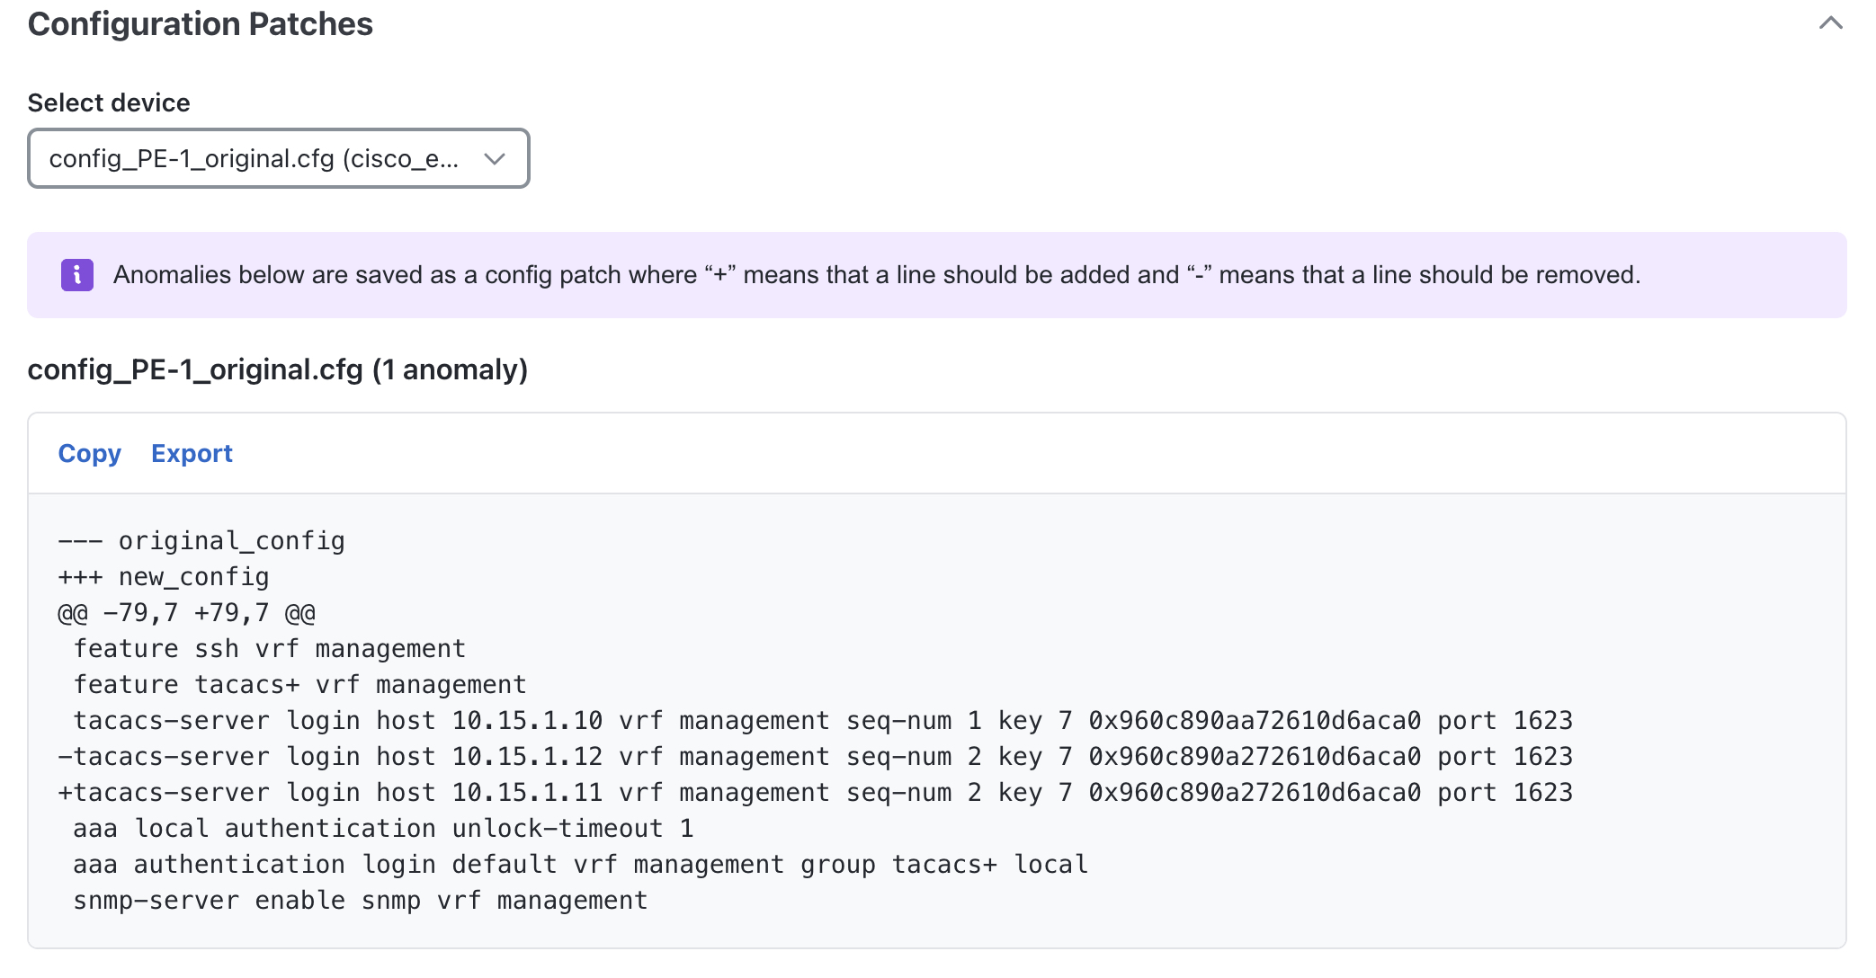  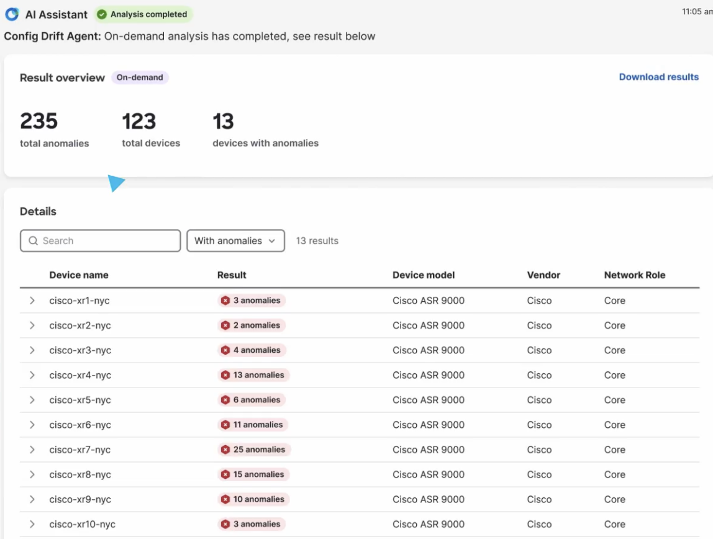 | We can see that configuration anomalies have been detected on two devices which are not along the service path.  There is a misconfiguration in device <x> that impacts path computation. Looks like we found the culprit.  There is also another anomaly detected on device <y> that is unrelated – but quite suspicious. Even though there doesn’t seem to be an immediate impact to the network, let’s address this “silent issue” now as well and not wait for the next scheduled configuration drift detection run.  (Alternative: Instead of detecting a second anomaly, we could just say: “Btw – if there were other anomalies that were unrelated to this incident – even “silent” issues, we would have still detected them via the next scheduled configuration drift detection run.”)
7 |  | Note that we did not have to instruct or pre-train to against golden configs. The agent knew what to look for—it analyzed the whole network to determine what “normal” looked like, then looked for deviations where there shouldn’t be.
8 | Button is provided suggesting next step:  “Get remediation plan for detected anomalies”  User selects this.  AI Assistant responds: “Thinking…  Checking with Crosswork Network Controller AI on recommended remediation.  Preparing results.  < Description of remediation plan:  - Apply configuration change <- interface TenGigE0/0/0/2 affinity flex-algo red blue +interface TenGigE0/0/0/2 affinity flex-algo blue > to device <x> via CNC  - Apply configuration change <tacacs-server login host 10.15.1.12 vrf management seq-num 2 key 7 0x960c890a272610d6aca0 port > to device <y> via CNC >.  Buttons are provided suggesting next steps:  “Proceed with deploying recommended remediation plan”  “Perform dry-run for recommended plan”  “Export recommended remediation plan”  User selects: “Proceed with deploying recommended remediation plan”  AI Assistant responds: “Proceeding with recommended plan:  Applying configuration change <interface TenGigE0/0/0/2 affinity flex-algo red blue +interface TenGigE0/0/0/2 affinity flex-algo blue> to device <x> via CNC.  Applying configuration change < -tacacs-server login host 10.15.1.12 vrf management seq-num 2 key 7 0x960c890a272610d6aca0 port> to device <y> via CNC >”  Card-8 is added with info on changes performed and the option to revert the change.  Optional: AI Assistant indicates: “Waiting for service recovery.”  In the backend, we wait for PCA to send the corresponding “clear” message. After some time, AI Assistant indicates: “Service delay has been restored to baseline levels”  Card-9 is added showing that delay is back to normal for service <service id>. | With this information, we can use the Crosswork Network Controller to get the recommended remediation plan to restore normal network operations.  From here we have options: we can do a dry-run, export the plan for a separate change process, or deploy it directly.  But we'll proceed with deploying the recommended remediation plan.  The assistant applies the changes - two new cards appear - one capturing what was changed and another confirming the service has been recovered
9 | User requests AI Canvas to generate a detailed report. | Now that we’ve averted disaster, we can do some sleuthing and figure out who made those changes!  Using built-in capabilities of AI Canvas, we can easily generate a detailed report to capture the issue and actions taken.

Script-2 (placeholder):

Frame | Talk Track | Visual
1 | So you are at work, on your lunch break, trying to figure out today’s Wordle when you start getting chat messages from your ops manager that you’re starting to get complaints from your offices in France and Spain about the network—it seems to be mostly fine, but there are periods where it gets really slow and apps are starting to timeout.
2 | Your mind immediately goes to the software upgrade you just completed yesterday to your backbone routers, but that does not make sense because your team testing it in the lab, you upgraded all your regions and only these two are complaining, and why is it only an intermittent issue?
3 | With no clear indicators, this is the kind of issue that take a while to diagnose, let alone fix. You can have your team re-check their validation tests in the lab, but beyond that, it could be any number of issues from out-of-band configuration updates to the impacted routers, to changed behavior from the new software update to transport issues that have nothing to do with your team.
4 | You could schedule an emergency maintenance window and rollback the software update, but it would be great to have something more definitive before taking such a radical step.
5 | This is one of the areas where AI really shines: taking in mountains of disparate data and finding patterns that are not immediately apparent and is the underlying concept behind of our first AIops use cases: Toxic Factor Detection
6 | With Toxic Factor Identification, we have an AI agent that will examine your operational event logs and a series of network and device attributes
7 | The agent will try and identity the common attributes of network events and provide you with a report of events it checked and any patterns to the attributes that correlate with those events.
8 | Let’s see what the agent finds in this scenario | [Start Demo Video]
9 | 00:00: The AI assistant provides suggestions on what analysis to perform. We select to run toxic factor detection. Then we select the time period for which to perform the analysis and the type of events of interest – which is BGP sessions down. We analyze these events.  00:17: Toxic factors are classified into three toxicity levels with increasing severity: low, moderate, major. One major and one moderate toxic factor were identified. The major toxic factor corresponds to the combination of a particular hardware revision and software version. This corresponds to 12 devices, which is 0.4% of the inventory – but, results in ~9% of the events. The software version alone is identified as a moderate toxic factor – with lower relative toxicity.  00:45: We can see how the events evolved over time per toxic factor. Until the 20th of April, BGP session down events are relatively low. Then they start to increase as the software upgrades started to get rolled out. They continue to increase in subsequent days – both for the major and the moderate toxic factors identified.  1:03: Having identified the culprit for the reported issues, we can proceed to take action to address this and prevent it from manifesting in other parts of the network. Relevant data can be exported from the AI assistant to facilitate next steps. | [Run video]
10 | Now this agent is something you can run as part of the troubleshooting process or have it run periodically to identify issues in the network before they become network events. | [Video ends]
11 | Let’s see what the agent came up with | Slide with screen grab of final report screen  (see below)
12 | [highlight and explain key aspects of the report] | Slide with screen grab of final report screen
13 | As you can see, the issue came down to BGP flaps caused by an interaction between the software and a specific router platform that just happened to be prevalent in France and Spain as those offices were part of an acquisition. | Slide with screen grab of final report screen
14 | In a matter of minutes, the Toxic Factor Detection agent saved your team hours of work trying to chase down this intermittent issue.  By identifying the issue here, you’ve also eliminated the issue from the rest of the network, even if it’s not manifested, thus increasing your mean time between network incidents. | [Blank screen]
15 | With your permission, the agent will then request that another group of agents scheduled and perform a software upgrade on the troublesome routers.  (performed via Crosswork Workflow Manager fleet upgrade)
16 | In the future, we’ll also give you the option to share your anonymized toxic factor report and see other customer’s reports to help you further avoid problems in the first place.
17 | This agent and another agent that detect changes in device configuration will be available this fall as features in Crosswork Network Controller and as skills for the Cisco AI Assistant.

